VNC served FP integration with Proto UI

This document will describe how to use “VNC served FP integration with Proto UI” and how to maintain this tool.

Design: “VNC served FP integration with Proto UI” - This tool is divided into three following parts:
- VNC Server
- VNC Client or VNC Client integrated in Proto UI
- Command Server

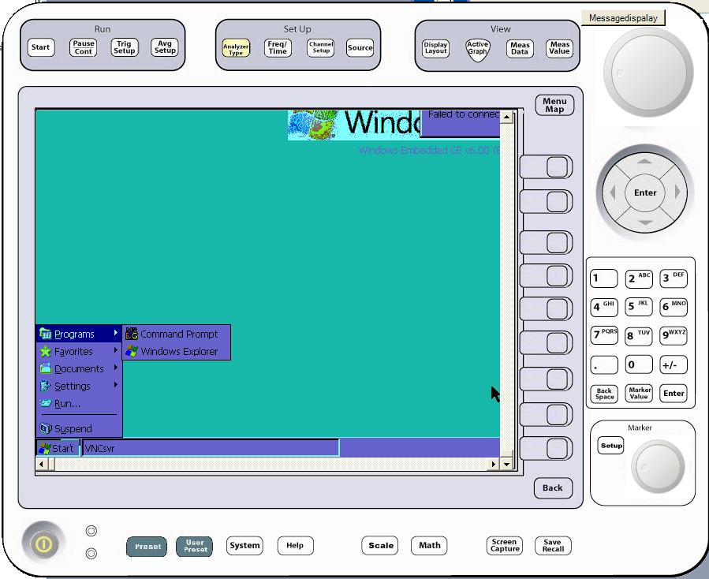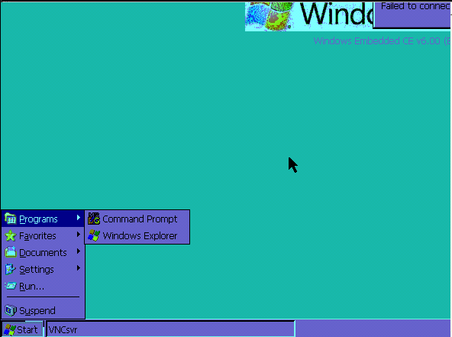
Proto UI
Mirage Instrument
Send Screen
Command
Cmd Server
VNC Screen Server

VNC Server – VNC Server has to run on the machine on which Mirage software is running it could be any PC or P2000 or Mirage Hardware, ideally it should be Mirage Hardware. We are planning to integrate it with in Mirage’s image. Its responsibility will be to send latest image of desktop on which it is running to VNC client.

VNC Client – WE have integrated VNC Client into Proto UI, so whenever a tester will run (Press Power button) Proto UI VNC Client will automatically start and it will ask for server’s IP and Port. Here server’s port is fixed which is displayed on Proto UI and tester can change server’s IP. When ever a tester will press any button on Proto UI a unique command will be forwarded to Command Server running in Mirage itself and depending upon the command Mirage will change its state/screen and now VNC server will send this changed screen to VNC Client.
Limitation: Before starting VNC Client Mirage must be in running state on its hardware.

Command Server: Its basic responsibility is to process the command coming from VNC Client and broadcast this command to Mirage system s that Mirage can change its state/screen. This command server will run inside Mirage software so a tester need not to do any special thing.
Command server and Mirage have a file common in them i.e. VNCCommand.xml, this file must remain in sync.

How to use this tool:
- Start Mirage on its hardware, this will start Command server and VNC Server (if VNC server is inbuilt in Mirage).
- If VNC Server is not inbuilt in Mirage then we have to deploy it on Mirage hardware and for this we need to install respective sdk on testers machine (from which we are deploying VNC Serevr).
- Run VNC client, Tester has to pass Server’s IP/port as an initial step. On pressing Power on button VNC Client will start showing Mirage’s screen on Proto UI

How to maintain “VNC served FP integration with Proto UI” - We have to take care of the following points to maintain this tool:
- What ever changes are being done on Proto UI must be done on VNC Client since then only it will reflect actual Mirage.
- If any thing is going to change on front panel of Proto UI or Mirage then we have to change VNCCommand.xml i.e we have to add respective command in VNCCommand.xml file.
- If we are changing VNCCommand.xml file on either side i.e. Mirage or VNC Client then we have to change the file on other side as well.

